Lab 2

A.

|  |  |  |  |  |  |
| --- | --- | --- | --- | --- | --- |
| Resistor | Theoretical Resistance | Minimum Resistance | Maximum Resistance | Actual Resistance | Percent Difference |
| R1 | 330 | 313.5 | 346.5 | 327 | 0.909% |
| R2 | 1500 | 1425 | 1575 | 1498 | 0.133% |
| R3 | 1000 | 950 | 1050 | 995 | 0.5% |

Table 3

|  |  |  |
| --- | --- | --- |
| Resistor | Measured Resistance | Calculated Resistance |
| Req | 598 | 600 |
| Rtot | 925 | 925 |

B.

Table 4

15.6 Volts read from mustimeter

|  |  |
| --- | --- |
| Voltage | Value |
| Unloaded Source | 15.6 V |
| Vs | 15.6 |
| V1 | 5.6 |
| Veq | 10 |
| Va | -5.6 |
| Vb | -10 |

Use tables to explain Table 4

Figure 7

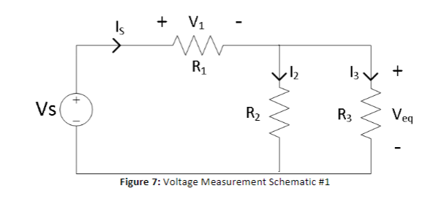

Figure 8

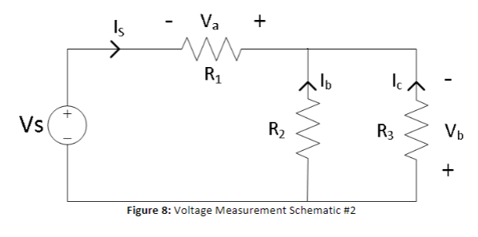

|  |  |
| --- | --- |
| Is | 16.91mA |
| I2 | 6.74 |
| I3 | 10.13 |
| Ib | -6.74 |
| Ic | -10.13 |

D.

I = Vt/(r1+req)

I = 15.6/(327+598) => 16.86mA

V1 = I*R1

V1 = 16.86 * 327 => 5.513v

Veq = I * Req

Veq = 16.86 * 0.598 => 10.082v

I2 = Is(R3/(R2+R3))

I2 = .01686 * (995/(1498 +995)) => 6.7mA

I3 = Is(R2/(R2+r3))

I3 = .01686 * (995/(995+1498)) => 10.13mA